EXPERIMENT – 1
1. Perform basic Image Handling and processing operations on the image is
to read an image in python and Convert an Image to Gray-scale.
Aim
To read an image using Python and OpenCV, and convert the image from color format to
grayscale.
Procedure
1. Import the OpenCV library using cv2.
2. Read the input image using the cv2.imread() function.
3. Check whether the image has been loaded successfully.
4. Convert the color image into grayscale using cv2.cvtColor().
5. Display the original image and the grayscale image using cv2.imshow().
6. Wait for a key press using cv2.waitKey().
7. Close all the displayed windows using cv2.destroyAllWindows().
Program
import cv2
image = cv2.imread("image.jpg")
if image is None:
print("Image not found!")
else:
gray = cv2.cvtColor(image, cv2.COLOR_BGR2GRAY)
cv2.imshow("Original Image", image)
cv2.imshow("Grayscale Image", gray)
cv2.waitKey(0)
cv2.destroyAllWindows()
Sample Input
Input image: image.jpg
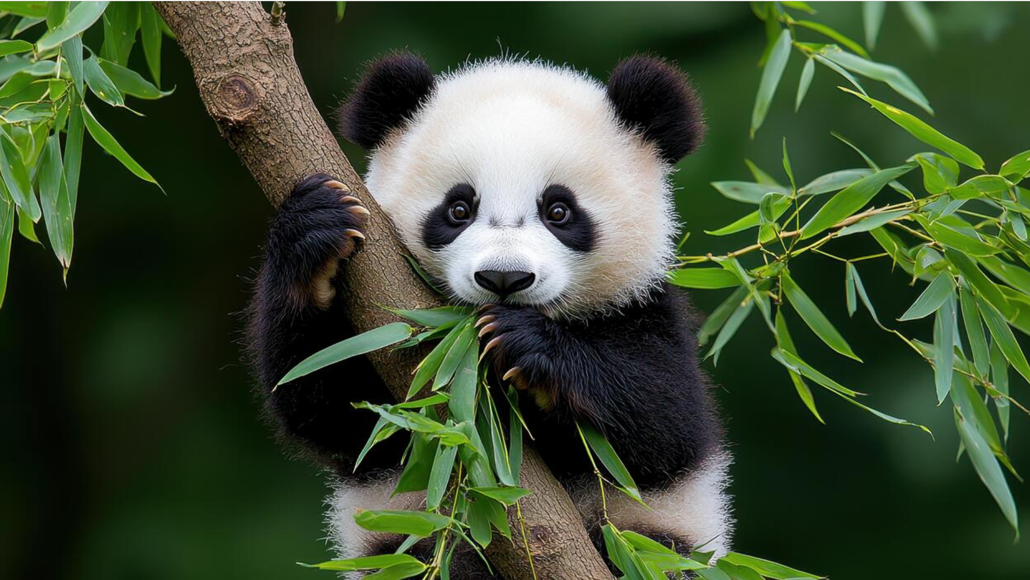
Sample Output:
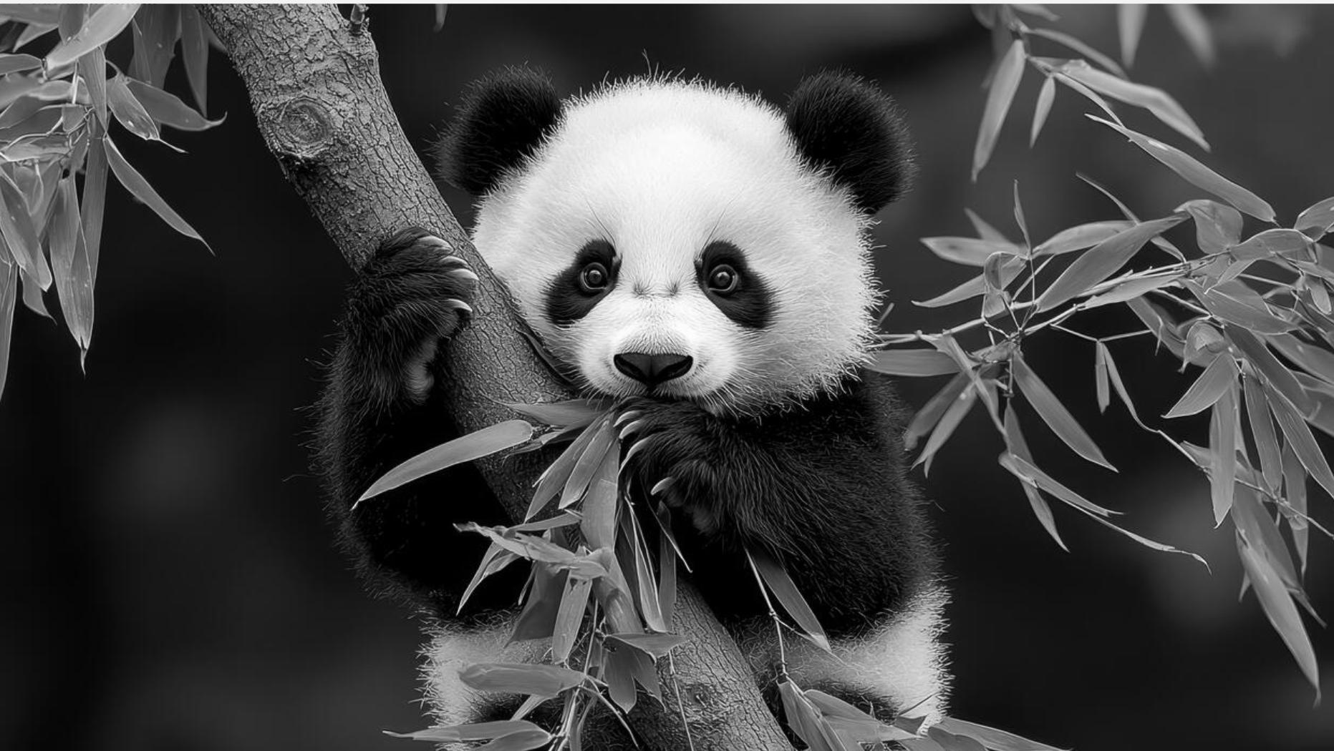
Result
Thus, the image was successfully read using Python and OpenCV and converted from a color
image to a grayscale image.

